MAY 2016
Success Story:
Cairn India
Cairn India is one of India’s largest oil and gas exploration and production companies in India and, along with its joint venture partners.

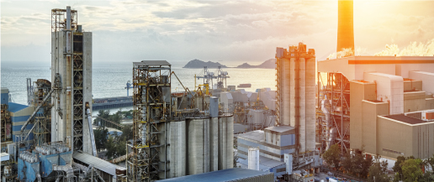

About Cairn India

Cairn India is one of India’s largest oil and gas exploration and production companies in India and, along with its joint venture partners, accounts for over 20 % of India’s domestic crude oil production.
Part of the London, UK headquartered, USD 14bn (2012) Vedanta Resources plc, Cairn India has revenues of USD 2.5bn (2012) with assets over USD 10bn.

Area of Implementation

Cairn India’s Mangala field is the largest onshore hydrocarbon discovery in India over the last two decades accounting for a production of 150,000 bopd (Barrel of Oil Per Day). The Mangala Processing Terminal (MPT) at Barmer (Rajasthan, India) spread across an area of 160 hectares,

is the crude oil processing hub for all of Cairn India’s fields in the Rajasthan block. It stands at the head of the world’s longest continuously heated and insulated pipeline at 670 kilometers (420 miles) terminating at an oil storage terminal in Bhogat (Gujarat, India).

Key Requirements
It is in the MPT that Cairn India sought to upgrade its existing access control infrastructure and also include a slew of features such as vehicle access management, paperless contractor and visitor management, a fire drill management and evacuation system and integration of these with their redesigned access control system.
For Cairn India, it was essential for the access right management solution to be centralized in order to accommodate Cairn and contractor employees working in the ever increasing well pads around MPT.

Challenges
Vedanta Resources plc is a global player in the metals and mining space. Its scorching pace of growth requires all group companies to setup and maintain high-quality core and supporting infrastructure. With the MPT being a strategic resource
Stringent Quality Requirements

The solution was also required to scale up and manage new well pads in the same development area (DA-1) and include the sites of Raageshwari, Aishwarya and Saraswati (DA-1) and Bhagyam and Shakti (DA-2). Plans for Kameshwari (DA-3) would also be rolled out on the same solution.
The MPT houses operations and the administration block, oil processing facilities, a command and control center, chemical Labs, fire stations, cafeterias and a medical center. All these were to come under the proposed access control system.

with many firsts in the world, requirements and standards set by Cairn India were even more stringent. Control and management of access for people and vehicles

contact@idcube.co.in
+91 - 120 - 4130715
www.idcubesystems.com
IDCUBE
Identification Systems Pvt. Ltd.

